A to Z Project
There are couple ways you can go with an A-Z project. First you can take pictures of things that look like the letters A-Z. Take a look at the photo above, it’s actually a chain to a porch swing, but the one piece looks like a letter S. Once you start this project you’ll start looking at ordinary things – buildings, cloud formations, playground equipment, etc. – in a complete different way, giving you a new perspective on things to photograph. This project can also be done with numbers, too.
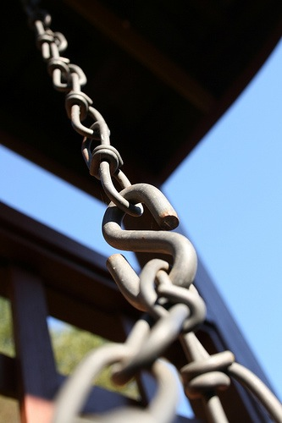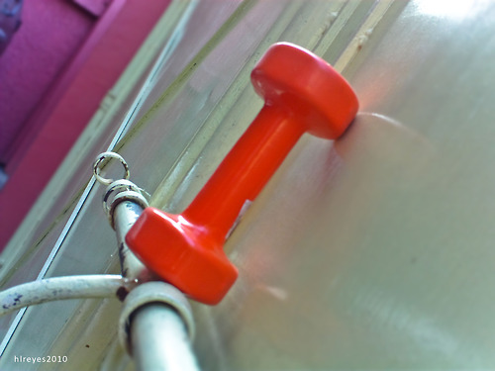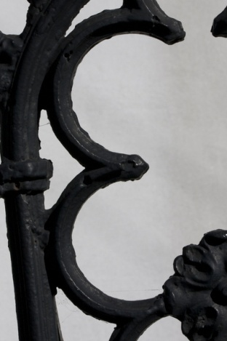
The other interpretation of this project is to pick a place and try to get a picture of objects that start with or represent each letter of the alphabet (for instance, it might be easy to take a photo of the grass for G, but Q is going to be harder, maybe a picture of a kid running around could be Quick, or a picture of a completely still pond could be Quiet).
Whichever method you choose, remember you can only use each idea for a letter once.

